# **CTF Challenge: Website Scanning- Using Observatory by Mozilla**



# **1. Introduction**



Observatory by Mozilla is a web-based tool that checks a website's security headers and overall security configuration. This challenge will introduce you to using Observatory by Mozilla to assess the security posture of a target website.

# **2. Tools and requirements**

* Access to the internet and Search for Observatory by Mozilla

# **3. Scenario**

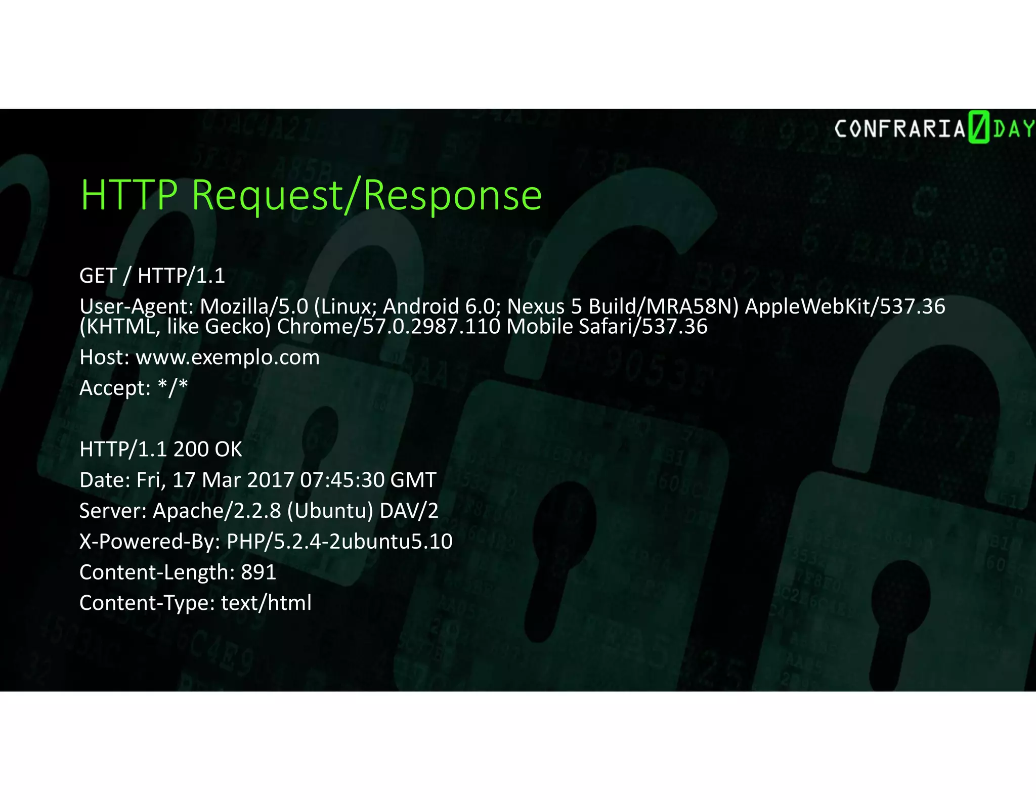

You are an ethical hacker tasked with analyzing the security headers and configuration of a target website using Observatory by Mozilla. Your job is to find the grade and any security headers detected.

# **4. Process to follow while performing CTF**

**Step 1: Visit Observatory by Mozilla:**

* + Go to the [**Observatory by Mozilla**](https://observatory.mozilla.org/)**.**

**Step 2: Enter the Website URL:**

* + Enter the URL [**https://islington.edu.np/**](https://islington.edu.np/) of the target website, start the scan and solve the CTF.

# **5. Let’s Begin the Challenge**

**Questions**

Flag 1: What is the security grade and any one security header detected on the target website?

Answer: C+

Flag Captured

Flag 2: What is Grade History Score?

Answer: 60

Flag Captured

Flag 3: What is CF-Cache-Status on Raw Server Header?

Answer: Dynamic

Flag Captured

**Hint**



